Chiara F. Kim
chiarafkim@gmail.com • 385-695-0396 • https://chiarakim2025.wixsite.com/portfolio
133 W 22nd St, Unit 9E, New York, NY, 10011

Owen Thiele Details How Being an 'Annoying Guest' at a Dinner Party with Alex Cooper Launched His Career (Exclusive)
The actor also talks about his close friendship with Sabrina Carpenter after appearing in 'A Nonsense Christmas'
By
Chiara Kim

Published on December 9, 2024 01:44PM EST
Comments
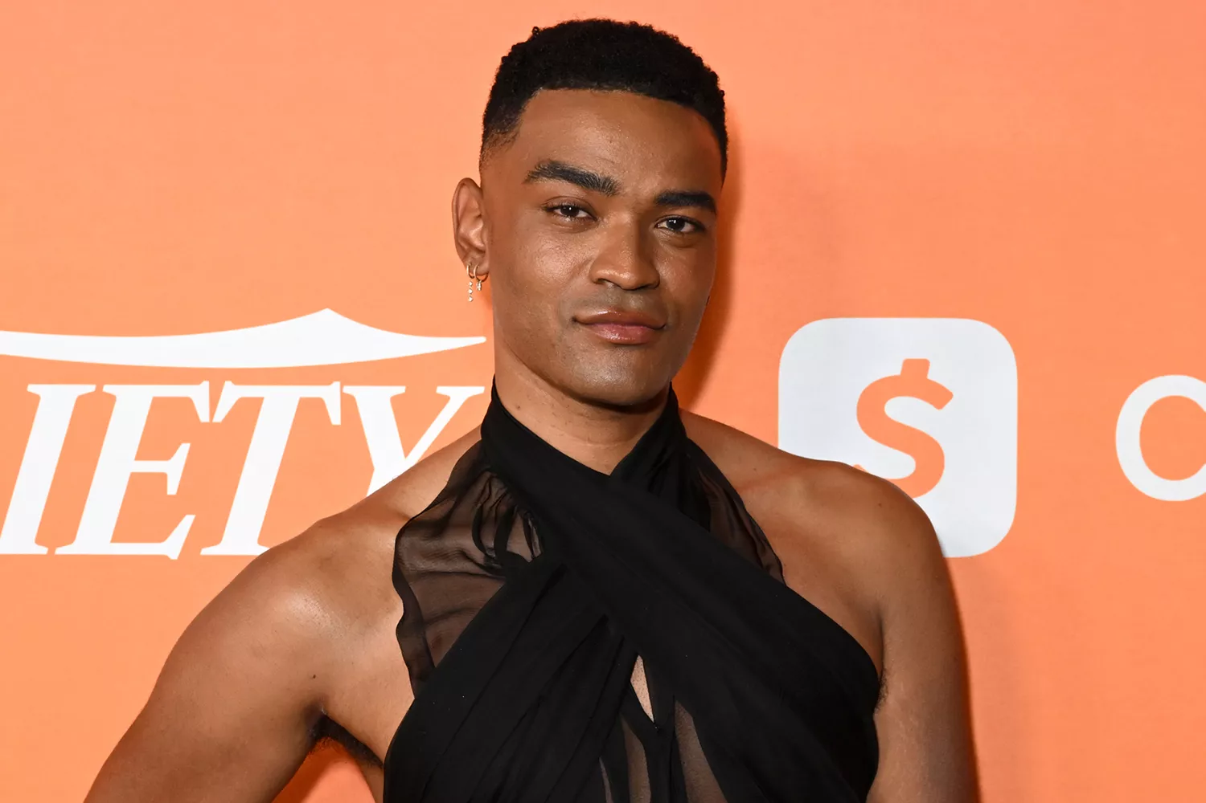
Owen Thiele.Credit :
Credit: Gilbert Flores/getty
Owen Thiele is talking his way to the top.
Following roles in Dollface and Theater Camp as well as Taylor Swift’s music video for “The Man,” the actor is gaining a whole new audience with his innovative podcast In Your Dreams under Alex Cooper’s Unwell Network.
Speaking exclusively with PEOPLE, Thiele opens up about his early beginnings and how a dinner party ended up launching his podcasting career.
“As Larry David would say, I was middling the table,” Thiele recalls. “I was being the annoying guest that was hogging all the attention. And Alex (Cooper) was like, ‘Wow, you should do this for a living.’”
From there, the idea for In Your Dreams was born. As he promoted the podcast on Cooper's Call Her Daddy, he immediately drew in new fans by candidly telling stories about sleeping with a frying pan in his bed and trying to FaceTune his driver's license.
Thiele tells PEOPLE that creating his podcast has been the "most fun experience” because he’s doing what he loves most — talking.

'In Your Dreams' podcast with Owen Thiele.
Credit: unwell network
As the title suggests, the podcast follows Thiele, an "undiagnosed insomniac," having conversations with star-studded guests in the wee hours of the morning, resulting in some interesting conversations.
In the first few episodes, he has featured famous friends such as Emma Chamberlain and Cazzie David, but the most rewarding part for him has been having real conversations. Though he thought he knew everything about close companions like Molly Gordon and Rachel Sennott, he learned even more about them on the podcast.
“There's new things that you unlock in your friendship, so that's been really, really fun,” he says.
While some of his guests are reluctant to film so early in the morning, he tries to convince as many of them as possible as a self-described night owl himself.
"I'm so awake at 3 a.m. or 4 a.m. or even 5 a.m., so that's when I love to record,” he says. “I’m kind of peak Owen at that time.”
He’s also having fun creating solo episodes about his relationship with fashion designer Jared Ellner, who styles Sabrina Carpenter.
“It's kind of like a diary for me,” he says of his podcast. “I can just speak into the void.”
Thiele recently appeared in A Nonsense Christmas with Sabrina Carpenter, whom he gushes is one of his "all-time favorite" artists right next to Taylor Swift.
"I am obsessed with her," Thiele said of the "Feather" singer. "Being anywhere near her is like, I faint and cry, and I ugly snot. It is such an honor."
He notes it's an added plus that his partner works with the singer on the regular, calling their collaboration "beautiful" as they make "brilliant" and "creative" choices together.
"It's really cool that my partner is working with somebody that I'm such a fan of," he continues. "It makes me emotional. They're two creative forces that have somehow found each other."
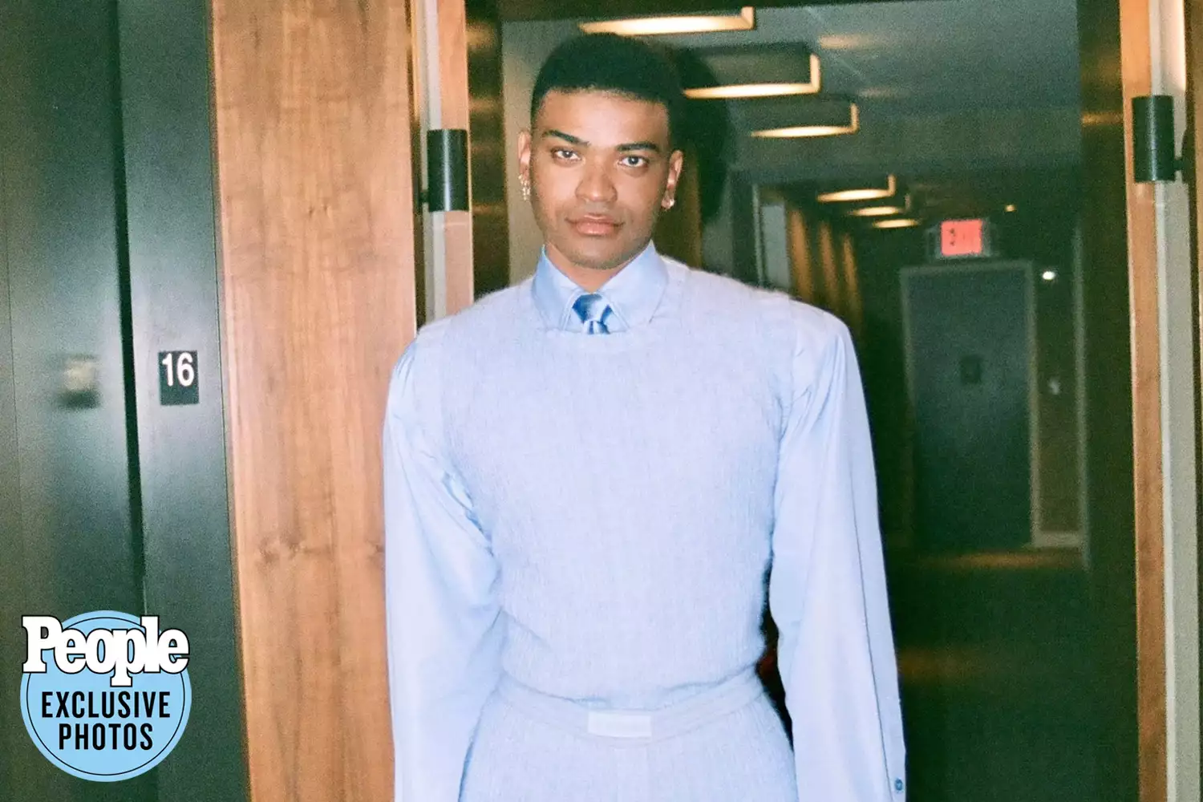
Owen Thiele.
Credit: Chelsea Gehr
Another person Thiele admires is his close friend Alex Cooper, who he says was a guiding light as he started his podcast under her Unwell Network.
“She's so skilled at it that it always seems so purposeful, and with me, it just felt like I was just speaking about nothing,” he says of how Cooper helped him. “I asked her if I was going down the right path at all, and she very kindly said, 'Yes, do what you do,' which is talk like you didn't take your ADHD medication, and hopefully it reaches people.”
He adds that Cooper is incredibly creative and wise, so he takes any advice he can get from her.
“I'm like, can we do this for the rest of our lives? I want to be 90 with Alex Cooper, holding hands, doing podcasts,” he jokes.
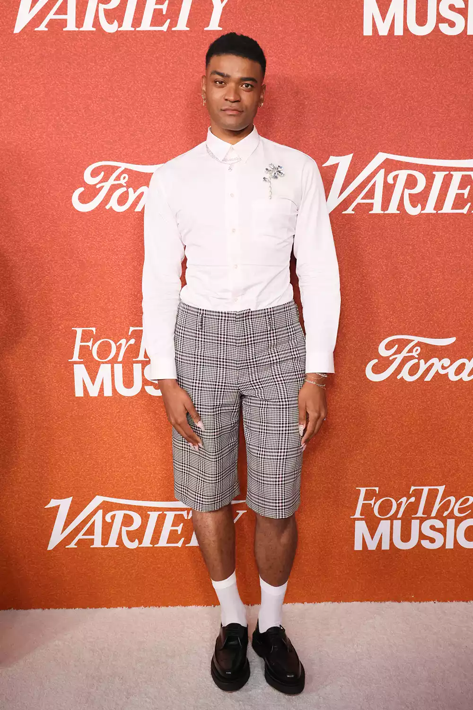
Owen Thiele at the 2023 'Variety' Power of Young Hollywood event.
Credit: Rodin Eckenroth/FilmMagic
Looking toward the future, Thiele wants to continue to build his audience and hone his podcasting skills.
“If somebody likes [In Your Dreams] or laughs at it, that's that's all I need,” he says.
One of In Your Dreams’ current biggest fans is Thiele’s mom — his “best friend in the world” — who he says sends him paragraphs with her thoughts after listening to each episode.
She also encourages Thiele to stay true to himself amid his rise to fame.
“She's just always been like, ‘Please continue to be yourself. It'll work in some way or another. If you're in finance or a podcaster or whatever you end up doing, at least you'll have you,’” he says.

What Are 2024's Buzziest Halloween Costumes? PEOPLE Staffers Guess the Top Looks — from Sabrina Carpenter to The Substance
Get ready to see viral costumes everywhere this Halloween — here are PEOPLE's best guesses
By
Chiara Kim

Updated on October 23, 2024 11:15AM EDT
Leave a Comment
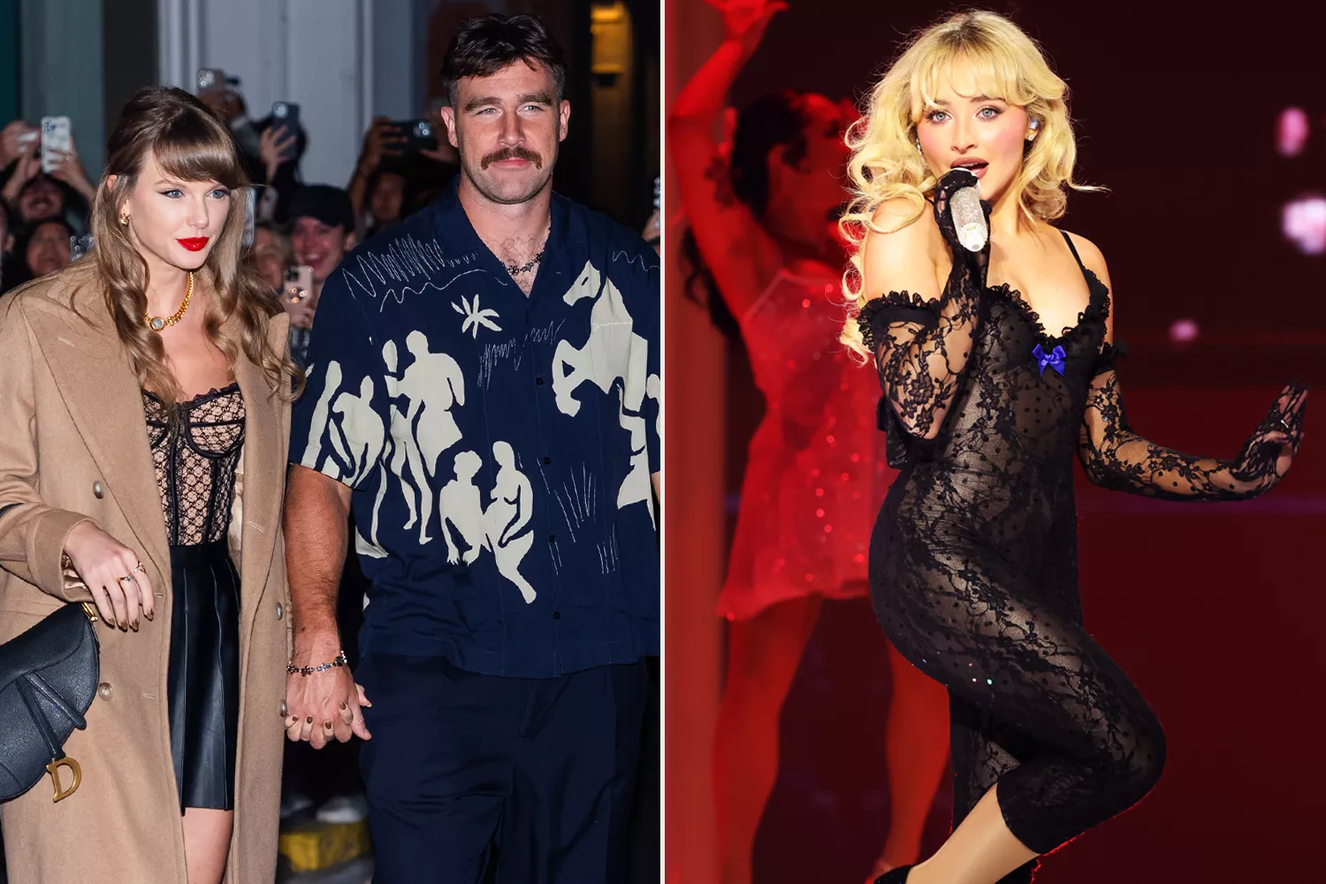
Taylor Swift and Travis Kelce; Sabrina Carpenter.
Credit: TheStewartofNY/GC Images; Kevin Mazur/Getty
Halloween is coming up quickly, and we can't help but wonder what the most popular costumes will be this year. There will certainly be lots of Sabrina Carpenter impersonators strutting on platform heels, while partygoers will undoubtedly embrace "brat fall."
On the other hand, conversation-starting costumes like MomTok and Raygun are sure to get a reaction.
And we can't forget about the moments that left us speechless this year, like that one French pole vaulter and those scenes in Challengers.
Pop stars, quotable movies and shows, Olympic memes and one pygmy hippo dominated pop culture this year. Here are the buzziest 2024 Halloween costumes (and how to style them!), according to PEOPLE staffers.

Taylor Swift and Travis Kelce

Taylor Swift; Travis Kelce.
Credit: Kate Green/Getty; David Eulitt/Getty
The pop star and Chiefs tight end dominated the stage and the football field this year. A sparkly pop star getup and a football jersey are key to dressing as America’s sweethearts. This costume idea is "So High School" — in the best way.

Sabrina Carpenter

Sabrina Carpenter.
Credit: Kevin Mazur/Getty
Here’s one way to leave “quite an impression!” The “Please Please Please” singer is everywhere — mimic her feminine style with a short n'sweet nightgown and platform boots.
Optional add-ons include lipstick marks, a mug for your "Espresso" and a dry sense of humor. The biggest hurdle might be achieving her larger-than-life hair that has vexed fans and media alike.
For significant others with a partner wearing a Carpenter-inspired costume, perhaps try a “white jacket and [a] thick accent”?

Secret Lives of Mormon Wives

The cast of 'The Secret Lives of Mormon Wives'.
Credit: Mayci Neeley/TikTok
We don’t know if MomTok is going to survive without people dressing as the iconic friend group for Halloween. The hugely popular Hulu reality show about mormon wives in Utah has already been picked up for a second season.
Celebrate by wearing a black top, jeans and wavy extensions while carrying a 44-ounce soda. A long, blue peacoat would be the cherry on top.

Moo Deng and Pesto
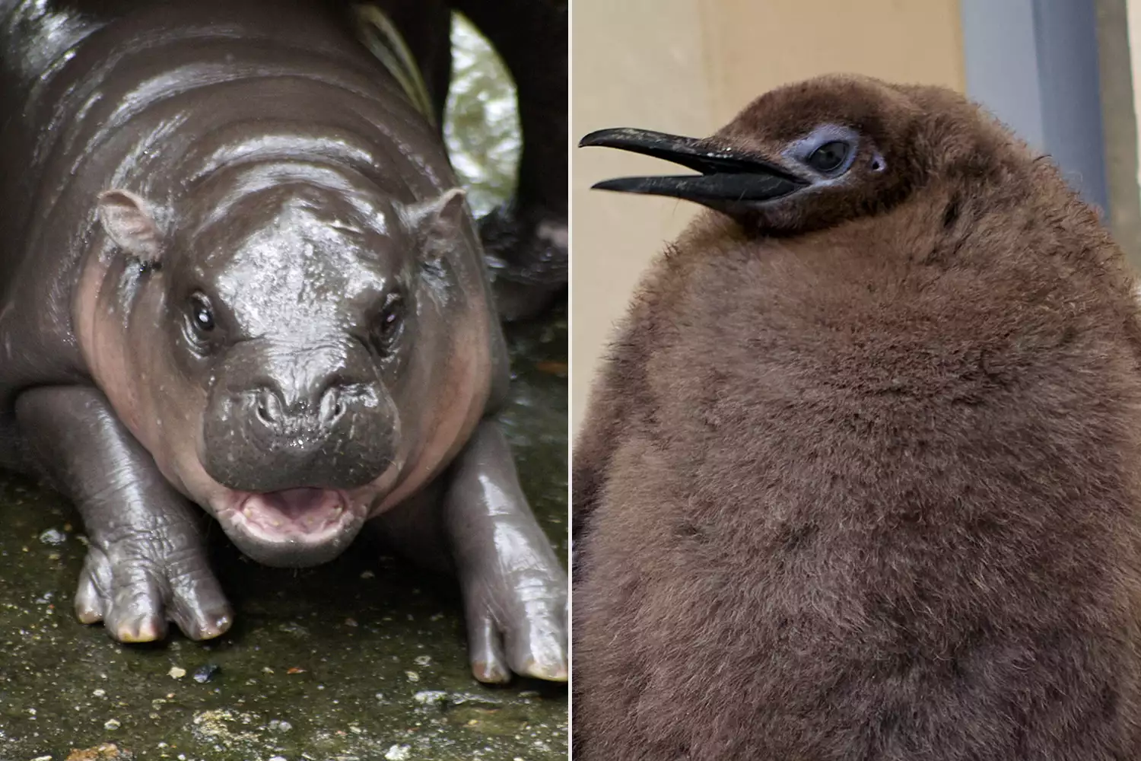
Moo Deng; Pesto.
Credit: Carola Frentzen/picture alliance via Getty; Sea Life Melbourne/AFP via Getty
The internet’s favorite animals this year are cute, quirky and distinctive — from Thai pygmy hippopotamus Moo Deng's penchant for biting to Australian penguin Pesto's sheer size. PEOPLE told you how to dress your pet as Moo Deng, but how does a human dress as one of these animals?
For Moo Deng, the key is personality — whatever you wear, make sure you pair it with disdainful, yet adorable, sass.
As for Pesto, something gray and fuzzy paired with extremely tall shoes will ensure you stand out in a crowd, just like the baby penguin.

Chappell Roan

Chappell Roan.
Credit: Erika Goldring/WireImage; Barry Brecheisen/WireImage
Chappell Roan exploded in popularity this year. Your “favorite artist’s favorite artist” has a trove of memorable outfits to be recreated.
Costumes inspired by her neon Lollapalooza boxer ensemble, her medieval MTV VMAs look or her Austin City Limits cowboy-inspired garb just might start a “femininomenon.”

Brat by Charli XCX
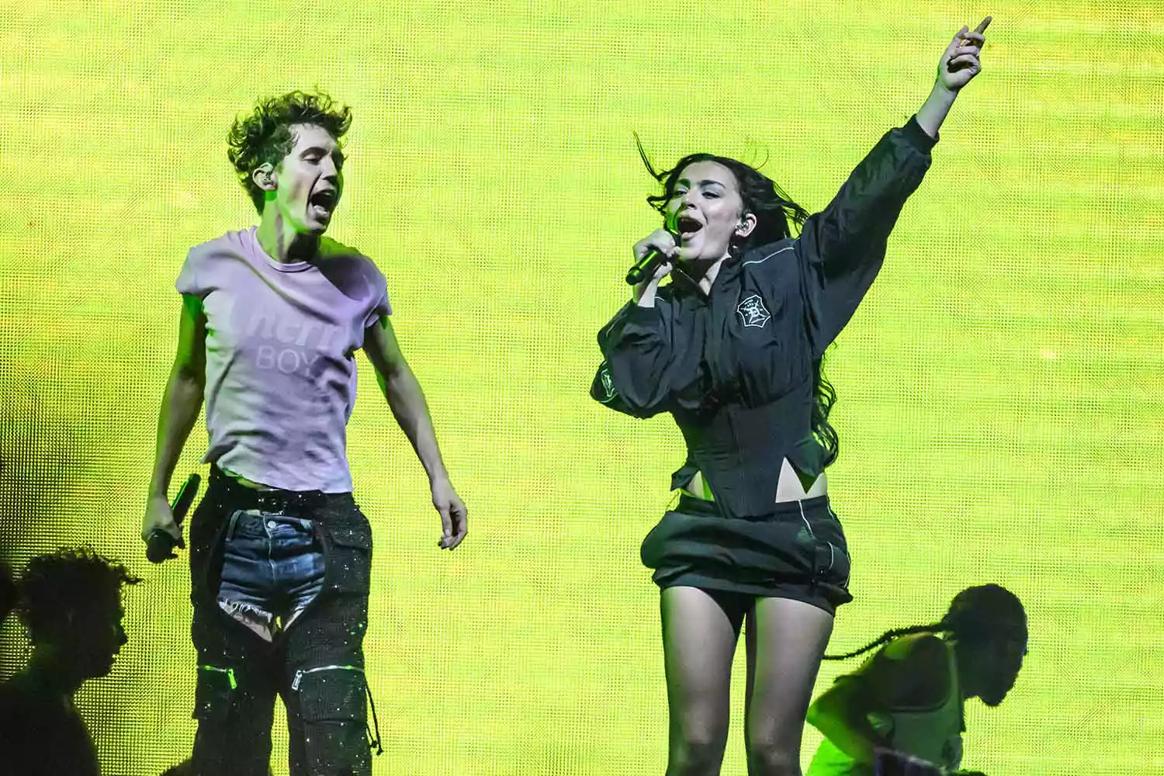
Troye Sivan and Charli XCX.
Credit: Katja Ogrin/Redferns
Brat and it’s completely different because it’s people dressing as Charli XCX for Halloween, but also still brat because they’re wearing "brat" green and the clubbiest clothes they own.
"Brat summer" has passed, but with the recently-finished Sweat Tour and the release of a reimagined brat album, one could certainly get away with dressing as the pop star herself, her Sweat tour companion Troye Sivan or “Guess” collaborator Billie Eilish.
Don’t forget to complete the look by “working it out on the remix” and matching costumes with your frenemy.

Wicked

Ariana Grande and Cynthia Erivo.
Credit: Universal Pictures
With an adaptation of the hit musical coming to the big screen on Nov. 22, featuring Ariana Grande and Cynthia Erivo, we’re sure musical theater devotees and Arianators alike will hit the town in flouncing pink skirts and tiaras or dramatic black gowns and witch hats.

Olivia Rodrigo

Credit: Christopher Polk/Billboard via Getty
With Olivia Rodrigo’s continued dominance (and viral moments) on her sold-out, 57-date Guts world tour, along with the Oct. 29 release of her concert film, pop fans would be “logical” to want to dress like the singer.
Channel the modern-day rock star with sparkly shorts, fishnet tights and anything purple.

Challengers
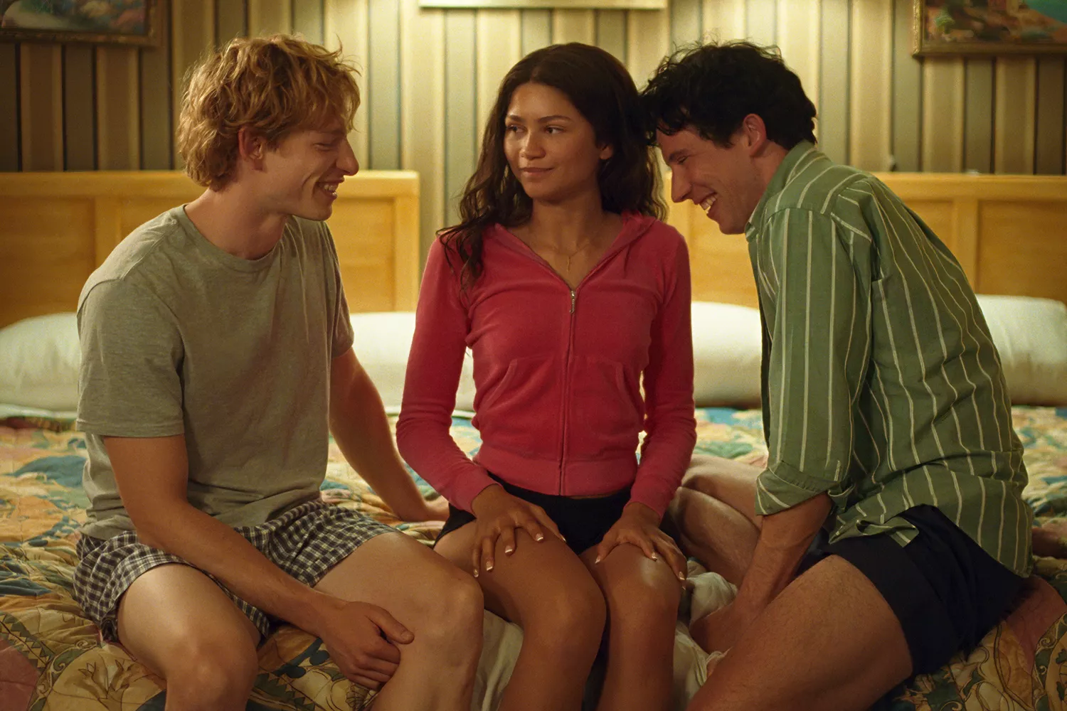
Mike Faist, Zendaya and Josh O'Connor.
Credit: Metro Goldwyn Mayer Pictures
Zendaya, Mike Faist and Josh O'Connor stunned viewers in Challengers with intermingling passionate connections.
The costume is perfect for a group of three, especially one with undefined relationships to one another. Elevate your typical tennis player costume with palpable tension, sustained eye contact and lots left unsaid.

Raygun
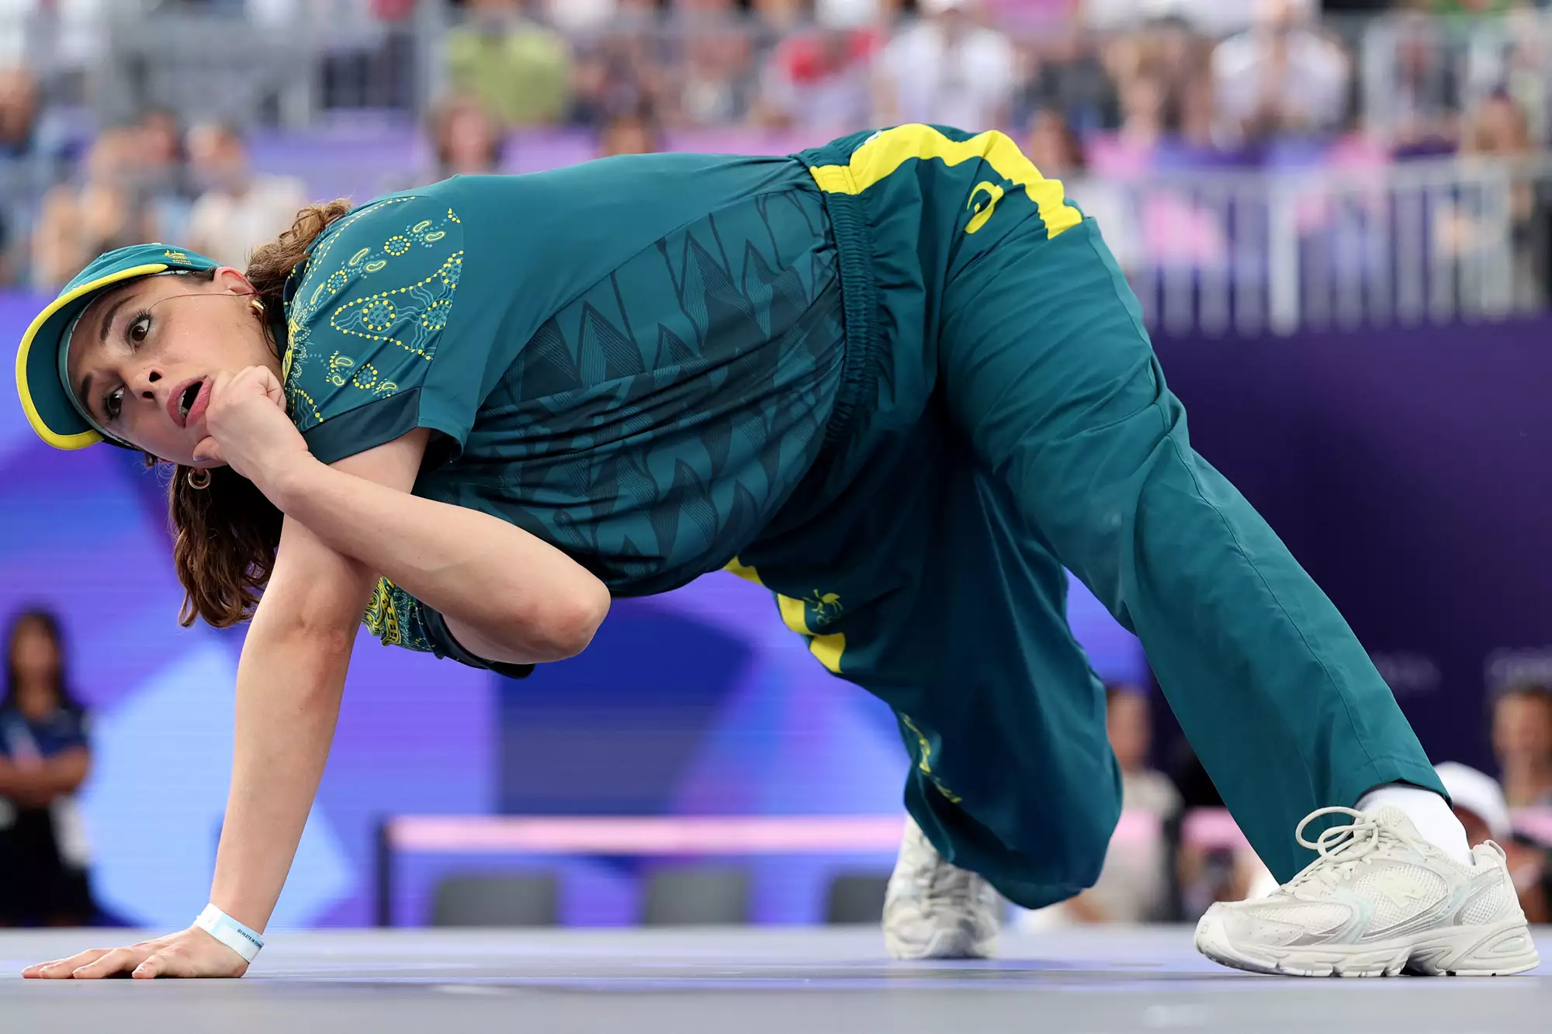
Raygun.
Credit: Elsa/Getty
The Australian breakdancer certainly left an impression at the 2024 Paris Olympics, despite scoring 0 points. The internet had quite a few things to say about the Raygun, and so may your friends if you show up to the Halloween function in green and yellow athletic wear with your own creative breakdance moves.

The French Pole Vaulter

Credit: Kevin Voigt/Getty
French pole vaulter Anthony Ammirati went viral for seemingly knocking over the crossbar with his “package.” (In reality, he first hit the bar with his shins and his knees).
Choose your own adventure with this one.

Sue from The Substance

Margaret Qualley in The Substance.
Credit: Alamy
It's time to pump it up!
While you may want to get crazy with prosthetics to emulate Elizabeth and Sue's final form from The Substance, we anticipate seeing a lot of spandex-clad, ponytailed girls out for Halloween this year.
Channel Margaret Qualley's character from the hit horror film with some fun, sparkly eye makeup, and bright, '80s-esque athleisure.

Michelle Zauner talks grief, love at One Book Keynote



Angeli Mittal/Daily Senior Staffer
Michelle Zauner discussed writing about grief and love in her One Book Keynote presentation Wednesday night.
Chiara Kim, Senior Staffer
October 18, 2023

Close to 1000 audience members crowded into Cahn Auditorium Wednesday evening to listen to author and musical artist Michelle Zauner’s One Book Keynote.

Zauner is the lead vocalist for Grammy-nominated alternative pop band Japanese Breakfast and the author of New York Times best-seller “Crying in H Mart,” this year’s One Book selection. The memoir focuses on Zauner’s relationship with her mother and explores themes of biracial identity, memory and love.

During the talk — moderated by history Prof. Ji-Yeon Yuh — Zauner touched on everything from how her grief management has evolved throughout her writing to her favorite things to cook. Zauner said she uses writing to understand her own feelings, but her work also resonated with many others in different ways.

“I think this book is really a love letter to my mom,” Zauner said. “When you write for yourself, you end up writing for so many people.”

Students and other attendees said they appreciated the relatability of Zauner’s memoir, particularly her focus on grief and tumultuous family relationships.

In his introduction at the event, University President Michael Schill said the book was “a surprisingly personal experience,” as he previously lived in Eugene, Oregon — one of the main settings of the book — and recently lost his mother.

Ph.D. candidate Donnisa Edmonds said she appreciated hearing about Zauner’s experiences –– both as a musician and as an author.

“I feel like the way she writes about grief is really relatable,” Edmonds said. “I was getting on the bus, and I teared up. I was like, ‘wow she’s crying in H Mart, I’m crying on the bus.’”

Zauner discussed how college was the first time she learned to truly appreciate her mother. She hopes that students and young adults call their mother after reading the book and have a newfound appreciation for their relationships with their parents, she said.

Communication freshman Breanna Lee said Zauner’s presentation was comforting and made her think of her mom. As a student from South Korea, Lee said Zauner’s upcoming project, a book about her experiences living in South Korea and learning Korean that she will write in 2024, made her think of her future.

“The way she’s exploring … what it’s like being an adult really resonated with me,” Lee said.

Zauner said her grief, while impossibly painful, has shown her how much she loves her mother.

Zauner told The Daily the book needed to be as “emotionally ragged” as it was in the period of her grief that she wrote it, but in the future she will continue writing about her mother in a more collected way. She also said everyone has a different relationship with their mother, so it is a special relationship to investigate.

“I guess (mother-daughter relationships are) something that many people can relate to and have personal and intense feeling towards,” Zauner told The Daily.

Zauner told the audience she feels like an outsider in both the United States and South Korea, leaving her with a “desperate desire to be understood and to feel a sense of belonging,” which she finds in creative spaces. She highlighted how writing allows her to bridge a connection to her audience.

“We all belong to each other in some way, and that’s really beautiful,” she said.

Students pursue passions and policies in summer research



Daily file illustration by Olivia Abeyta
From passion projects to policy recommendations many students this summer are conducting research on every topic imaginable with support from the University.
Chiara Kim, Senior Staffer
June 27, 2024

When trying to go to downtown Chicago, rising Weinberg junior Jun Park realized the Purple Line often doesn’t come on time. He sometimes found himself stuck at Howard station for 20 minutes. He decided to use this summer to research solutions for Chicago’s public transportation system.

From passion projects to policy recommendations, Park and other Northwestern students are conducting research on every topic imaginable with support from the University.

Park is looking at Singapore’s public transport because he said it is known for being reliable and safe and cutting down car usage. Park’s research question is whether Singapore’s centralized governance — the Land Transport Authority — is more effective than Chicago’s divided agencies — the CTA, Metra and Pace, particularly for minority populations.

Park received the Ginsberg Research Grant through the political science department to fund his flight to Singapore. Ahead of the trip, he is trying to schedule interviews with migrant workers. Currently, he said, Singapore does not allow them to use public transportation for work, instead using trucks for transport. While they are allowed to use public transport in their free time, Park said they tend to live in areas where such infrastructure does not exist.

Park wants to see whether having a centralized governing system deprioritizes the needs of certain populations like migrant workers. He hopes to write a policy recommendation for Chicago and other U.S. cities.

Rising Weinberg junior Ethan Bledsoe is using his passion for environmental and data science to ponder another issue in Chicago — health disparities near warehouses. Bledsoe said redlining and other policies have disproportionately hurt low income communities and communities of color by placing warehouses and other pollution hotspots near them.

The research process so far, Bledsoe said, has involved reading papers and manipulating data with the programming language R.

Bledsoe became interested in this topic through Climate Change Research Group meetings, where weekly paper discussions familiarized him with environmental modeling topics and jargon. Working with CCRG made summer research less overwhelming for Bledsoe. He became interested in the health impact side and the statistics the group produced.

“I’d done a lot of climate activism growing up and at home, but what I always really enjoyed (was) reading about the statistics that scientists would make,” he said. “I was like, ‘Oh, I could help make some of these statistics as part of my project.’”

He wants to develop statistics about disproportionate health impacts in Chicago for policymakers and activists.

Bledsoe was awarded a Summer Undergraduate Research Grant, a $4,000 stipend for eight weeks of full-time research. He appreciates the flexibility of the program, which allows proposals from all majors. His SURG advisor, Daniel Horton, is the CCRG leader.

Rising Weinberg senior Trevor Chau, has explored his interest in inorganic chemistry in the Hunter Lab over the past year.

Chau works on electrocatalytic processes, which he said is taking a solution, putting something in it, and passing electricity through it through electrodes to see what happens. This summer, Chau is working with blue dimer — two ruthenium atoms bound together by an oxygen atom. He is researching how to stabilize it in an oxygen evolution reaction, a chemical process producing molecular oxygen.
Chau said his work involves running reactions, prepping solutions and analyzing data. While he and other members of the lab help one another, he said his project is independent.

The work is sometimes tedious, Chau said, as he waits for reactions to run and for tests to come in. At times, he waits at his computer for half an hour. Chau learned that while we always hear about massive breakthroughs in science, “that doesn’t happen in a vacuum.”

“It takes a lot of time to get through it, a lot of trial and error,” he said. “I’m just permuting over and over…it’s rewarding to see progress.’”

Rising Weinberg junior and SURG recipient Lauren Dain took a personal route for her summer research. Her hobby is running marathons, so she is researching how athletic brands and sponsors have influenced women’s marathoning over time.

Women were originally banned from running marathons, so Dain was interested in the “women’s equality journey” and culture of female marathoning. She was curious about why participation in marathons has surged for women in the past 20 years.

Dain is conducting archival research — reading books on early female marathoners — and interviewing runners ranging from recreational marathoners to semi-professional runners. The unique stories and the barriers these women have faced have been the most interesting part of her research, Dain said.

“Women’s running shoes weren’t around until the early 80s, so a lot of women were just running in literal tennis shoes or men’s shoes. There were no sports bras,” Dain said. “(Things that) I think a lot of people in sports take for granted now, people didn’t have, even 50 years ago.”

Dain said she is going to synthesize the history of women’s marathoning into a blog with four installments.

This summer, Dain has learned to focus on meeting her goals. No one is telling her what to do each day, so she has to be self-directed. SURG has been a good learning experience about independent research, she said.

She said she mainly applied for SURG because she felt it was unique to the college experience to be able to research this “passion project” that isn’t necessarily tied to her academic plan.

“I’m very lucky to be able to just talk to all these really cool runners and read these books and develop this project,” she said.

“Turn that despair into hopefulness”: Students and experts talk climate anxiety, potential solutions

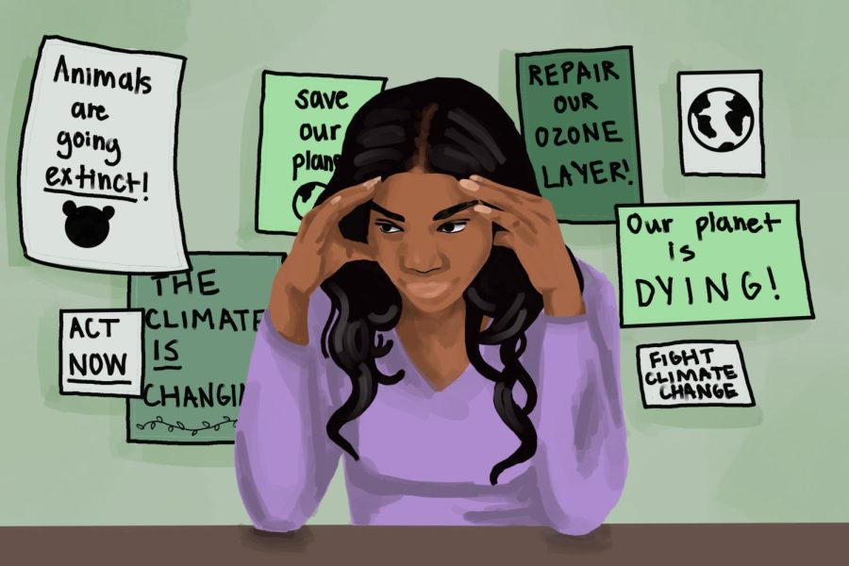

Illustration by Lily Ogburn
Students and experts discuss the “hopeless” feeling of climate anxiety and the importance of fostering community and taking action to combat it.
Chiara Kim, Senior Staffer
May 15, 2023
When campus environmental activists recently met Weinberg senior Hannah Dembosky, a member of the Associated Student Government Sustainability Committee, said she asked meeting participants what Earth Day meant to them.

While some felt hopeful people still care about the Earth, others were less optimistic. Some fellow activists, she said, find it difficult to keep fighting for action.
“(Activism) can feel like a constant pushing up against something that’s not really moving at all,” she said.

Dembosky said she thinks addressing climate change is “hopeless” and makes her feel a “very existential dread.” She isn’t alone –– a study published in The Lancet in December 2021 found that almost 60% of people between 16 and 25 feel “very” or “extremely” worried about climate change.
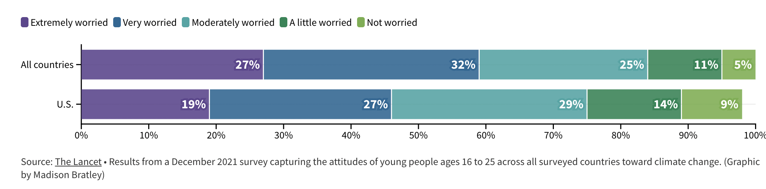
A Flourish chart
Mental health experts coined the term “climate anxiety” to describe the distress some people undergo when thinking about climate change. Medill Prof. Abigail Foerstner said climate anxiety describes worries about the future, climate change’s current progression and fear over the lack of a transformative response.

“All of these situations make you feel very vulnerable,” she said. “This is no longer looking ahead at how will this impact us in the future. We can see it now.”

Explaining the root causes of climate anxiety

Foerstner said the Intergovernmental Panel on Climate Change, the United Nations body that assesses science related to climate change, showed extreme weather caused by climate change is creating irreversible losses.

Her environmental reporting students tell her they feel an existential dread because they feel it’s up to them to address climate change, she added. For others, their anxiety stems from their experiences with climate-related disasters.

“Anyone from the Atlantic coast and the Gulf has seen horrific damage from hurricanes to their own families or to people that they know and care about,” she said. “This creates uncertainty and worry.”

Michele Forjette is a member of the Climate Psychology Alliance North America, which is a network of climate-aware therapists. She said displacement due to climate disasters can also cause anxiety.

“One of the biggest things that’s been coming up with people is that they feel like they’re not heard,” she said. “Sometimes they feel that they’re being told that they’re exaggerating.”

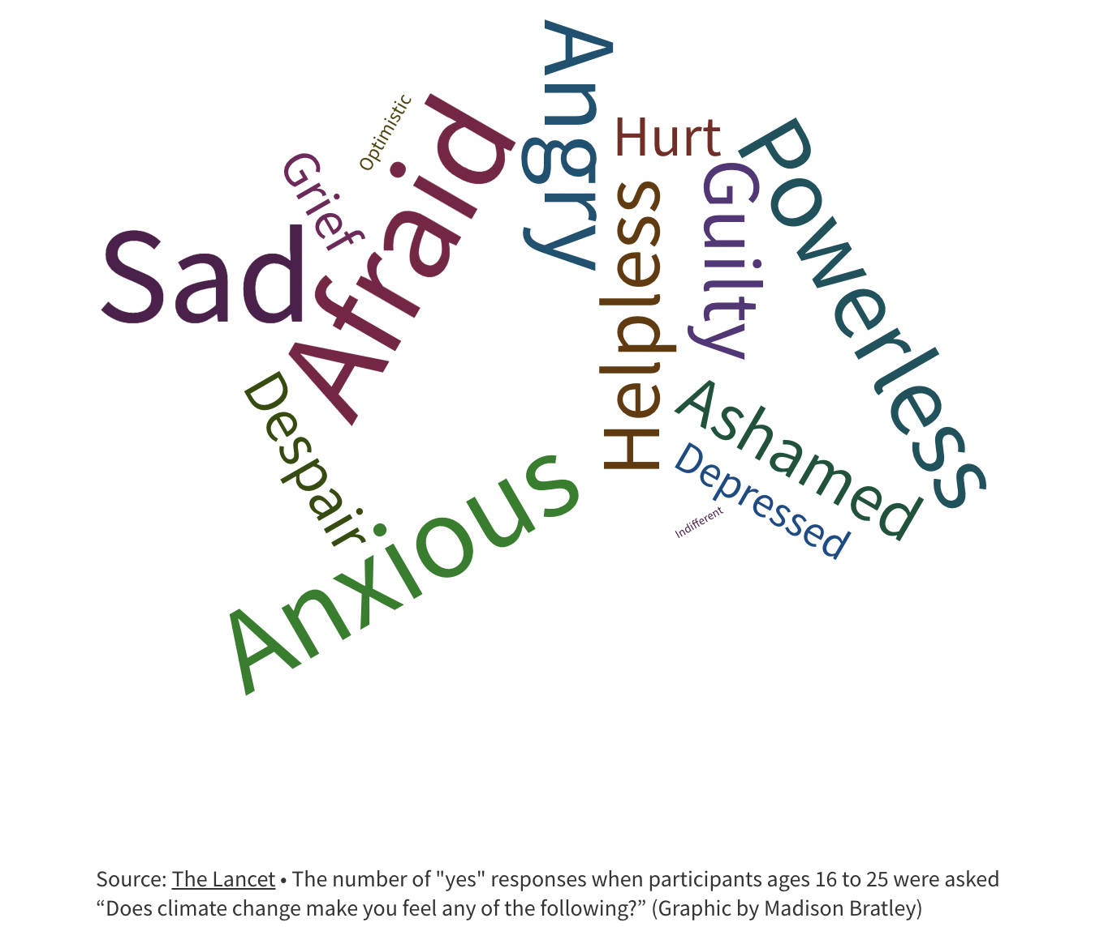
A Flourish data visualization
Fostering empathy in solution building

SESP freshman Anusha Kumar said her stress grows when she hears about how the U.S. and other countries are not taking adequate steps to solve climate change.

Marginalized communities experience the effects of climate change earlier and to a greater extent, according to a 2021 U.S. Environmental Protection Agency Report. Kumar said this reality amplifies climate anxiety.

Forjette said she has noticed climate distress surrounding displacement and uncertainty from people with marginalized identities.

“It’s our (climate therapists) responsibility to educate ourselves … and then really listen to the individual and use those skills to help identify their sources of strength,” she said.

Forjette said she sees mental health impacted by climate concerns after disasters and in response to other stressors –– like younger people thinking about how they will cope with change.

Addressing climate anxiety requires validating people’s emotions and helping them process, she said.

“What can be really helpful with that is tapping into their resilience and helping them to stay in the moment,” she said. “They can turn that despair into hopefulness.”

Solutions centered around community building, activism

Forjette said maintaining healthy habits, reducing stress and practicing mindfulness can help mitigate climate anxiety. She highlighted the importance of “eco-empathy,” safe communities in which people can discuss their stress about climate change.
Creating a plan for emergencies is also important for anxiety reduction. Forjette also recommends learning basic response training.

Weinberg sophomore Alexis Schwartz, co-chair of the ASG Sustainability Committee, said her climate anxiety stems from convincing people to care. She feels she is not doing enough for the Earth, but talking with others experiencing similar feelings is helpful.

Last year, Schwartz said the ASG Sustainability Committee partnered with One Book One Northwestern to host climate cafés –– inclusive spaces fostering conversation about climate change.

Schwartz said NU’s sustainability community provides a helpful interconnection for easing climate anxiety.

“We can pull each other out of (those feelings), and that’s why I think the community aspect of sustainability is really important,” she said.

Recently, the ASG Sustainability Committee’s Earth Day GREENOUT event helped promote environmentalism on campus through education and performances. Foerstner also said initiatives like campus gardens and local volunteering help ease students’ fears about a lack of action.

“Students are really picking up that commitment,” she said. “When we feel we’re doing something, and especially when we see our action taking place within our community, I think that relieves anxiety.”

Dembosky said environmental activism has become a “coping mechanism” for her, allowing her to feel like she’s making a difference.

As a member of Fossil Free NU, Kumar also uses advocacy to alleviate her climate anxiety. She is helping fight for the University to divest from fossil fuels.

While she emphasized the importance of understanding climate change is out of an individuals’ hands, there are still things she thinks people can help with.

“Everyone has different capacities, and I think a big thing is meeting people where they are,” she said. “Prioritizing taking care of yourself, and then also if you have the capacity, taking action within your local community is really important.”

